Krita Setup: The Fedora Version

Preamble

To contribute to the Krita project, the first step one should take is to build the program from the source code. This is… easier said than done (depending on the state of the latest Krita repo).

The Krita documentation has some excellent instructions for this:
https://docs.krita.org/en/untranslatable_pages/building_krita.html#building-krita-from-source

– with some quirks which this alternate/supplementary documentation is written to address.

This guide takes an alternative and thorough approach to building Krita; via Fedora.

Justification

The later Krita versions include some libraries that are not included in Ubuntu’s package manager, Apt, which can make installation difficult.

Fedora Workstation is a linux distribution which is intended for software developers, the packages of which are kept more up to date than Ubuntu’s (even accounting for backporting). This reduces the headache of attempting to import Krita’s many dependencies.

So, without further ado, a thorough guide to building Krita from source.

Instructions

Note: These instructions assume Windows but should be fairly universal.

1. Download your VM sandbox manager of choice. Mine is VirtualBox: https://www.virtualbox.org/

2. Download an ISO of Fedora Workstation. https://getfedora.org/en/workstation/download/

3. Set up a Fedora VM on your VM Manager. The following sub-instructions cover VirtualBox.

3a. Add a new machine on VirtualBox.
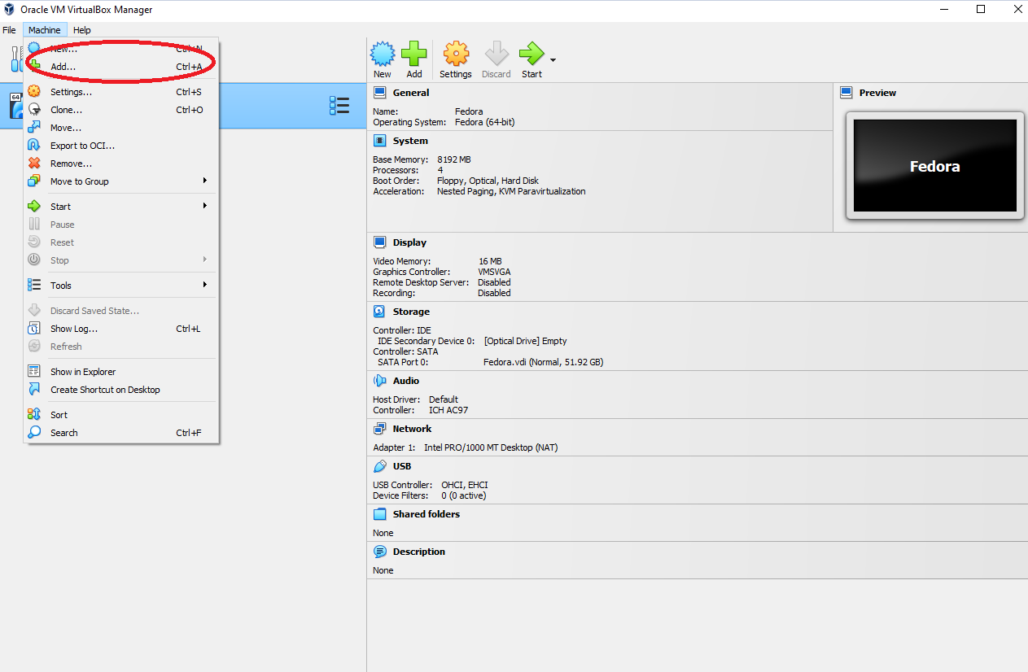

3b.

